**Derivation of Supply Curve of PV.**

Seungho Jeona, Gildong Hongb, Gyeonggi Dob,[1]*

a *Climate & Environment Data Center, Gyeonggi Research Institute, South Korea*

b *Climate & Environment Data Center, Gyeonggi Research Institute, South Korea*

**Abstract**

This is an abstract.

**Keywords:** Keword1, Keword-2, Keyword-3

1. Introduction

sssdfsssssssssssssssssssssssssssssssssssssssssssssssssssssssssssssssssssssssssss

This is an introduction.

This is the second chapter.

ssssssssssssssssss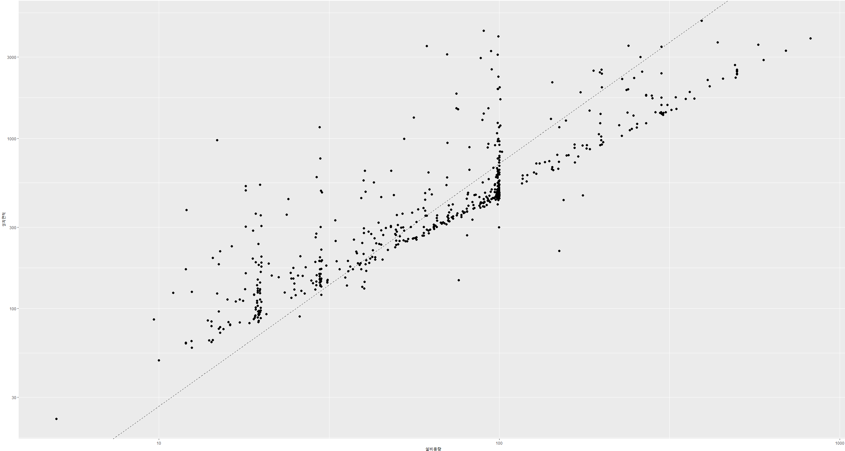

1. Methodology
   1. Classification of land-use and PV types

GCAM

* 1. Exploration of PV-available sites
     1. GIS-based approach
     2. Geographical constraint
  2. Calculation of PV potential
     1. Parameters for calculating PV potential
     2. Calculation of the PV potential
  3. Derivation of supply curve for PV
     1. Parameters for calculating LCOE
     2. Calculation of LCOE
  4. Gini coefficient

Gini

1. Results
   1. Electricity sector

Sdfsd ElecitGeographical $$G_{t,s}=1- \sum_{r=1}^{229}{{(X}_{r,t,s}-X_{r-1,t,s}){(Y}_{r,t,s}+ Y_{r-1, t,s})}$$

ssssssssssssssssssssssssssssssssssssssssssssssssssssssssssssssssssssssssssssssssssssssssssssssssssssssssssssssssssssssssssssssssssssssssssssssss

* 1. Implications for T&D networks

The last ssssssssssssssssssssssssssssssssssssssssssssssssssssssssssssssssssss

sssssssssssssssssssssssssssssssssssssssssssssssssssssssssssssssssssssssssssssssssssssssssssssssssssssssssssssssssssssssssssssssssssssssss

1. Conclusion

Electrification ssssssssssssssssssssssssssssssssssssssssssssssssssssssssssssssssssssssssssssssssssssssss

**CRediT authorship contribution statement**

**Seungho Jeon:** ABC. **Gildong Hong:** ABC. **Gyeonggi Do:** ABC

**Declaration of competing interest**

The authors declare that they have no know competing financial interests or personal relationships that could have appeared to influence the work reported in this paper.

**Acknowledgement**

This work was supported by the 'Gyeonggi RE100 Platform Establishment' project through the Gyeonggi Research Institute, funded by Gyeonggi-do.

References

1. * Corresponding author.

   *E-mail addresses:* [shjeon@gri.re.kr](mailto:shjeon@gri.re.kr) (S. Jeon), [rohmin9122@gmail.com](mailto:rohmin9122@gmail.com) (M. Roh), [k123mt@ajou.ac.kr](mailto:k123mt@ajou.ac.kr) (M. Kim), [jaeickoh@gmail.com](mailto:jaeickoh@gmail.com) (J. Oh), [suduk@ajou.ac.kr](mailto:suduk@ajou.ac.kr) (S. Kim)